**ADVANCE EXCEL ASSIGNMENT 09**

**1. What are the different margins options and do we adjust the margins of**

**the excel worksheet?**

There are four margins you can specify: top, bottom, left, and right. Each margin refers to the distance from the edge of the paper to where the information in your worksheet can be printed.

To better align an Excel worksheet on a printed page, you can change margins, specify custom margins, or centre the worksheet—either horizontally or vertically on the page. Excel for the web

Page margins are the blank spaces between your data and the edges of the printed page. Top and bottom page margins can be used for things such as headers, footers, and page numbers.

**2. Set a background for your table created.**

Click the worksheet that you want to display with a sheet background. Make sure that only one worksheet is selected. On the Page Layout tab, in the Page Setup group, click Background. Select the picture that you want to use for the sheet background, and then click Insert.

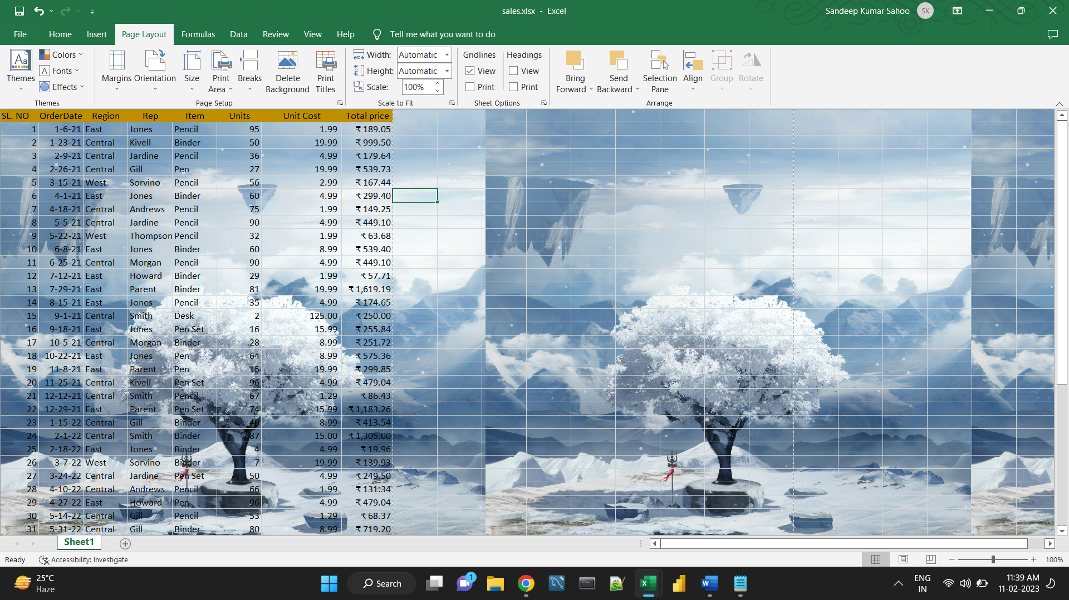

**3. What is freeze panes and why do we use freeze panes? Give**

**examples.**

To keep an area of a worksheet visible while you scroll to another area of the worksheet, go to the View tab, where you can Freeze Panes to lock specific rows and columns in place, or you can Split panes to create separate windows of the same worksheet.

For example, if the first row in your spreadsheet contains labels, you might freeze that row to make sure that the column labels remain visible as you scroll down in your spreadsheet.

**4. What are the different features available within the Freeze Panes**

**command?**

Three different types of Freeze panes are there i.e.

* 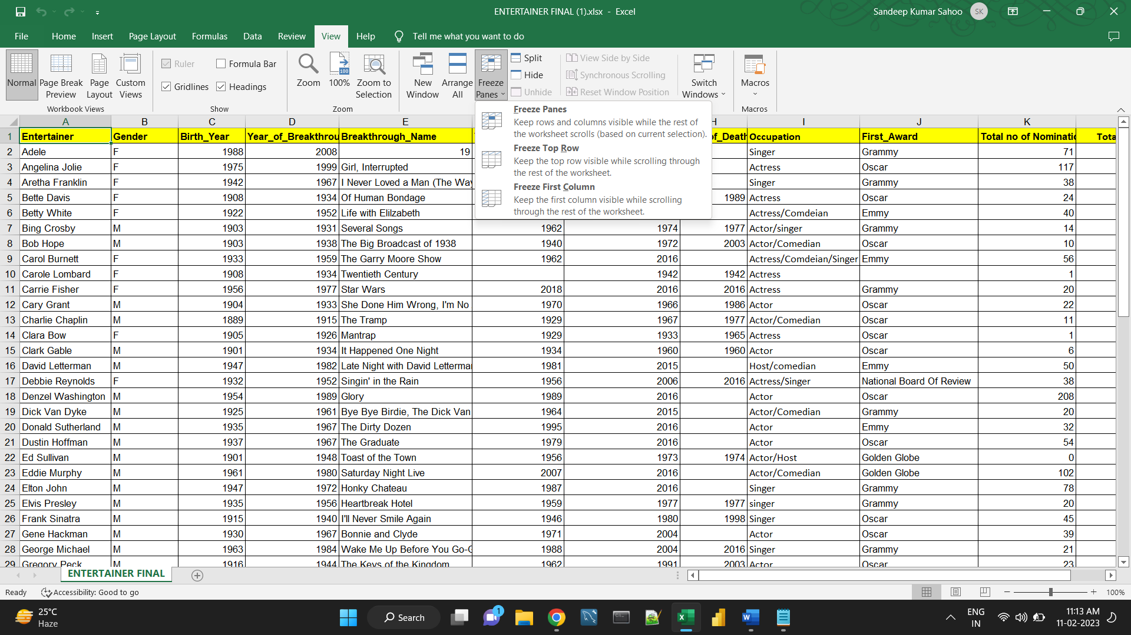Freeze Panes
* Freeze Top Row
* Freeze First Column

**5. Explain what the different sheet options present in excel are and what**

**they do?**

Since an Excel sheet is one of the core elements of the workbook, there are multiple core options to perform from the Sheet Options. We can access various sheet options by using the following ways:

* Ribbon Sheet Options
* Right-click Sheet Options

**Ribbon Sheet Options**

Excel has all the basic and advanced options present on its ribbon. Likewise, some quick sheet options are also present on the Excel ribbon and can be accessed by going to **Page Layout > Sheet Options.** It mainly has four toggle options: two for **Gridlines** and two for **Headings,** and they can be turned on and off by selecting and deselecting the checkboxes.

* **Gridlines:**
  + **View:** This option allows users to show/ hide gridlines within the active worksheet. Turning off this option removes the gridlines from the sheet and displays a blank Excel sheet.
  + **Print:** This option allows users to show/ hide gridlines on an Excel document that will be printed on paper.



* **Headings:**



* + **View:** This option allows users to show/ hide headings within the active worksheet. Turning off this option removes the headings from the current sheet's headers and footers.
  + **Print:** This option allows users to show/ hide headings on an Excel document, which is to be printed on paper.

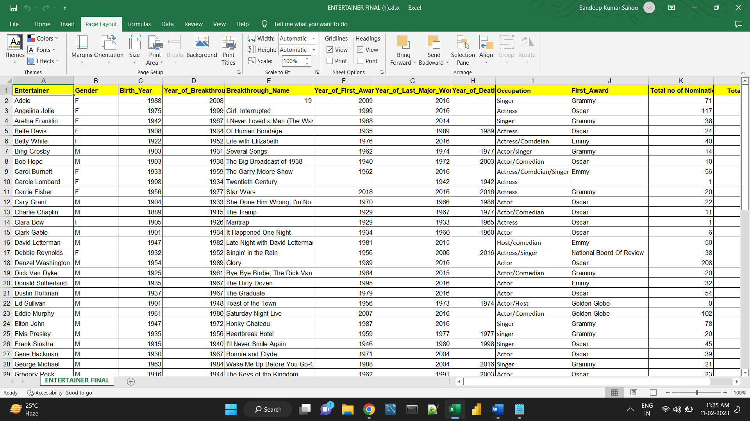



### Sheet Options in Dialogue Box under Page Setup

After clicking on the 'More' option (the arrow icon on the corner of the Sheet Options group on the ribbon), we get various sheet options. These sheet options are mainly used to adjust preferences for printing purposes. For instance, when we print Excel documents, gridlines are not usually printed. We can adjust preferences from sheet options to include the gridlines to print and manage other sheet options.

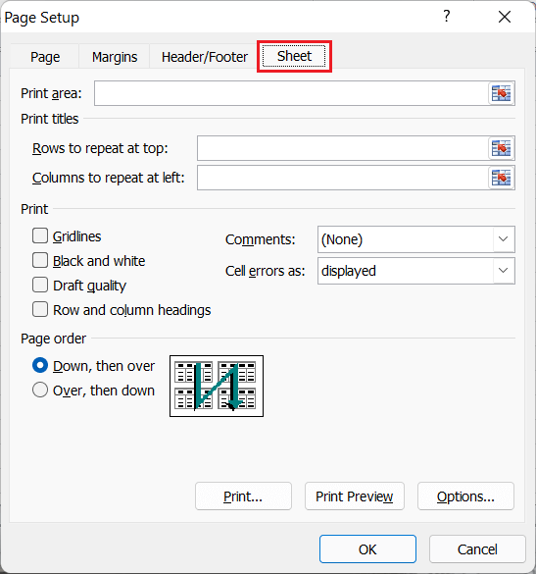

* **Print Area:** We can select the print area using this option. We can drag and select the area or range of cells by using the mouse.
* **Print Titles:**
  + **Rows to repeat at top:** This option helps us select the title to display at the top for corresponding rows.
  + **Columns to repeat at left:** This option helps us select the title to display on the left side for columns.
* **Print:**
  + **Gridlines:** This option can be enabled or disabled by selecting/ deselecting the checkbox. It helps us decide whether to show gridlines or not on printed Excel documents.
  + **Black & White:** Like the gridlines, we can select this checkbox to print the current Excel document in black and white color, even if we have the color printer attached.
  + **Draft Quality:** Selecting the checkbox associated with the draft quality allows us to print the Excel document using the printer's draft-quality settings.
  + **Rows & Column Heading:** We can select this option to display rows and columns headings to the printed Excel documents.
* **Page Order:**
  + **Down, then Over:** This option allows users to print the down page first and then the right pages.
  + **Over, then Down:** This option allows users to print the right pages first and then the down pages.
* **Print:** Clicking on this option gives a command to the device to print the current Excel document using the default printer.
* **Print Preview:** This option displays the preview of the Excel document that will be printed on paper.
* **Options:** This option allows users to choose layout type (portrait or landscape) and paper mode (A4, A5, etc.) for the Excel document to be printed.

**Right-click Sheet Options**

In Excel, the right-click with mouse button usually displays the context menu for the selected element. When we press the right-click on any Sheet tabs, Excel displays a list of options relevant to Excel sheets. The list includes various sheet options. However, this list is usually called the 'worksheet menu'.

The right-click sheet options are shown in the following image:

